Minutes of the IQAC Students Meeting on 16/08/2022, 10.00 am
A meeting of the IQAC student representatives nominated by all the departments was held on 16.08.2022 at 10.00 am in the Chandrasekhara Bharathi Theertha Seminar Hall. In total, 59 students actively participated, presented various grievances and proposed suggestions for improvement of College discipline, academic and non-academic improvements and maintenance requirements of existing infrastructure. The points which came up during the 3 hours long meeting are tabulated below.
The students were briefed on IQAC, its functions and importance in the day-to-day affairs of the college. The students were asked to pass on the information to their classmates too. They were also reminded to get all the google forms (on career guidance) and feedback forms (students, parents) filled by all classmates.
BVoc students had a special session at the end of the general meeting. IQAC requested them to submit their grievances and suggestions as consolidated form in writing, to the IQAC.
Ananya (DC II Biotechnology) and Amal Anil (DC II History) were selected as student IQAC representatives to IQAC core committee.
Teachers present:
- Dr. Biju Thomas
- Sri. S. Prasad
- Smt. Gopika G
- Dr. Manju T
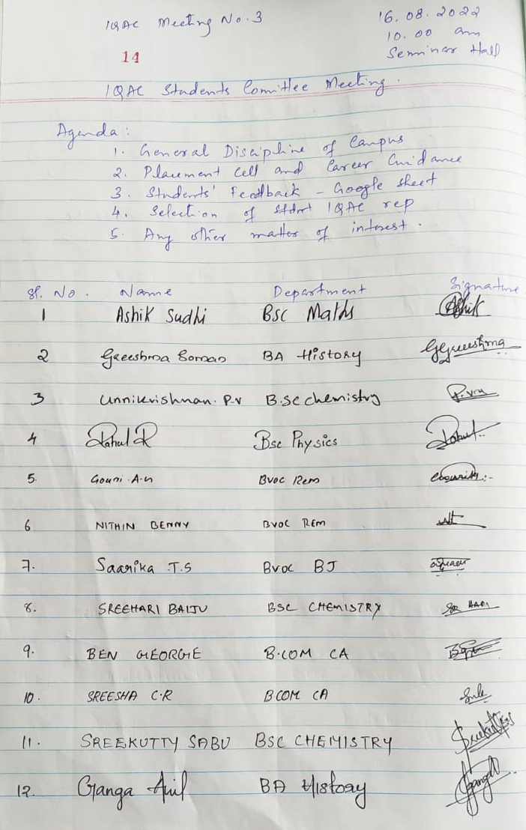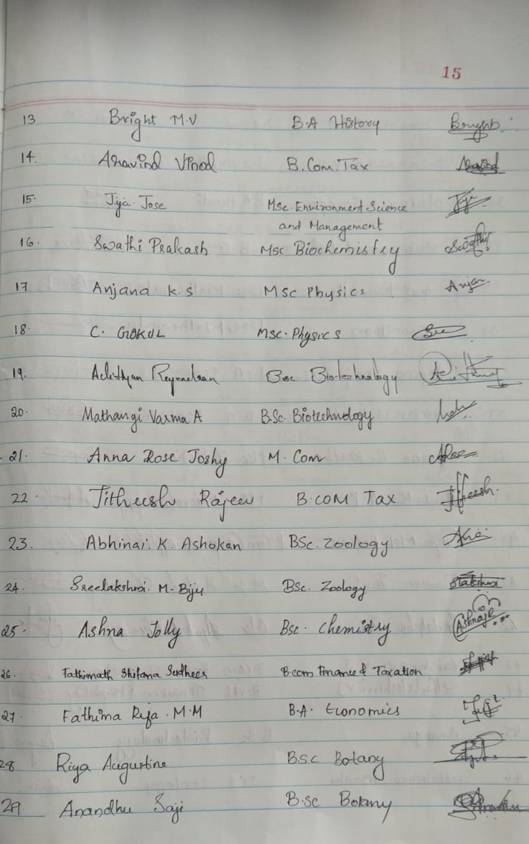

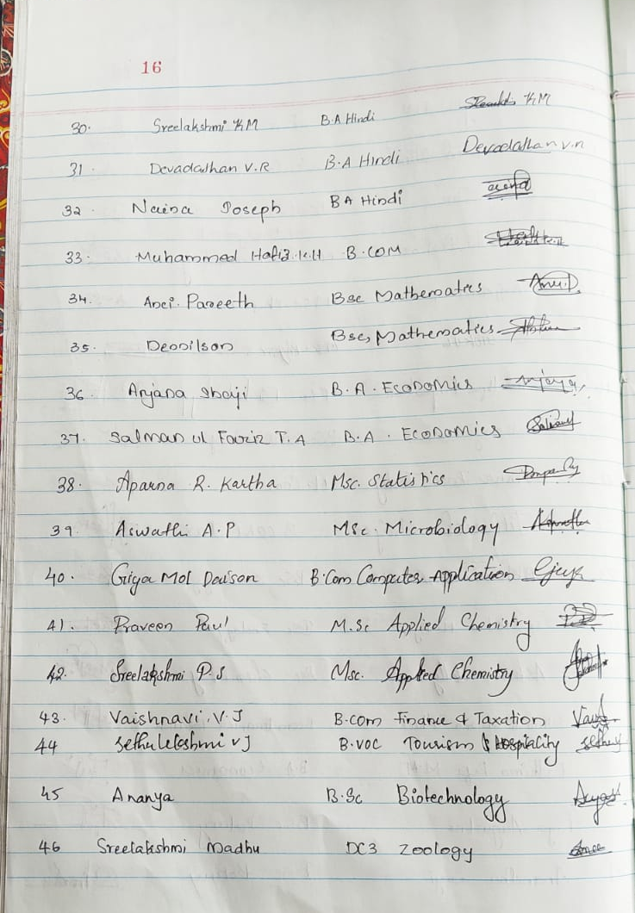
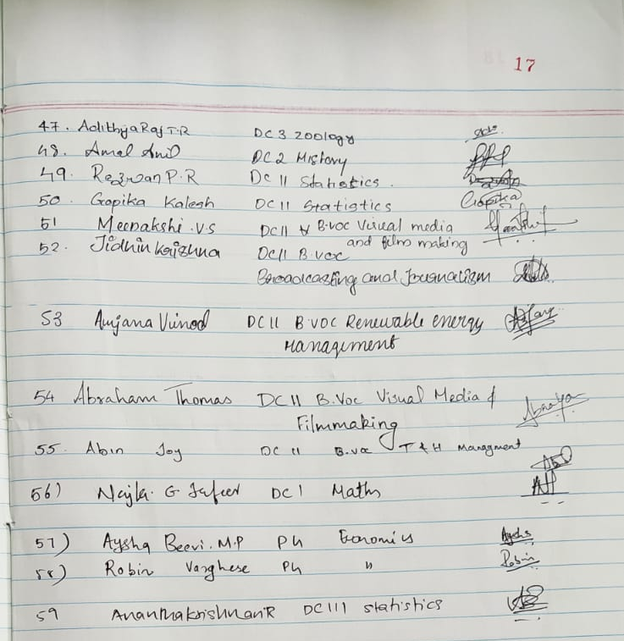
Sl. No. | Grievances and Requirements | Response from IQAC
CAMPUS DISCIPLINE
1. | Campus discipline to be strictly monitored | Measures started
2. | Carrying of ID Cards to be strictly implemented | Measures started
3. | Intruders to the campus need strict control | Recommended strict implementation of possession of ID cards by students, so that they can produce anytime on demand
4. | Gate register needs to be maintained | Need to discuss
5. | Night stays, drug abuse and alcohol usage to be prohibited | Recommended to Principal
6. | NCC room, beer bottles, girls insecure | CCTV cameras to be repaired and monitored – recommended
7. | Students who have submitted ID cards in offices, etc. need to get a letter from the concerned person. | Recommended to the Principal
8. | Campaigning during class hours: Time restriction to be implemented | Recommended to the Principal
9. | Intruders from other departments in Zoology lab – mishandling lab equipment | Recommended students to be vigilant and report to department on the spot
10. | Zoology + Botany-Common English classroom may be shifted to T block from S block | Recommended to the Principal
11. | Alumni card for outgoing students so that they can visit colleges during special days | Recommended to the Principal
12. | Students continuously bunking classes and is affecting quality of teaching (BVoc) – attendance to be properly marked | Recommended to the Principal
ADMINISTRATIVE
13. | e-grants release delayed | Need verification - Recommended to the Principal
14. | Attitudes Library and Office staff (general and SF) need to be friendly, supportive and polite | Brought to the notice of the Principal
15. | Office lunch break interval needs to be modified so that students are not forced to bunk classes for office visits | Recommended to the Principal
16. | Students need to wait too long at office counters. Sometimes just to hear that staff is absent / you are standing at wrong counter, etc. | Brought to the notice of the Principal
ACADEMIC
17. | Blackboards and whiteboards need cleaning | To be recommended to the Works Committee
18. | Library to be open from 8.30 am onwards to help students visit. | Library is already open from 8.30 am onwards
19. | Catalogue corrections needed. Books available in the racks shown as “not found” | Recommended to the Librarian
20. | Library hour for PG – one hour to be allocated every week | Recommended to the Principal
21. | NET coaching for PG students requested (higher studies entrance test coaching also) | Recommended to Dept heads
22. | Employability skill enhancement programmes needed | Recommended to the Career Guidance and Placement Cell
23. | Career guidance classes and meetings from Career Guidance cell requested | Recommended to the Career Guidance and Placement Cell
24. | An interval of 10 minutes after first two hours requested | Recommended to the Principal
25. | Computer repair | Recommended to the Principal and IT Cell
26. | EVS lab facilities need improvement | Recommended to the Principal
27. | B. Voc. lab hours to be done parallelly with theory hours. Avoid last minute lab sessions | Recommended to the Principal to instruct BVoc Faculty members
28. | Visual Media lab infrastructure poor | Recommended to the Principal
29. | Internships need to be provided by the college in association with companies with Linkages, collaborations, MoUs, etc. | Recommended to the Principal to instruct BVoc Faculty members
INFRASTRUCTURE
30. | More two-wheeler parking space needed | Recommended
31. | Basket Ball Court needs cleaning and clearing | Recommended
32. | Seats/Stone benches needed in campus (Poonchola) | Recommended
33. | Music/Dance/Drama rooms need to be identified in the campus | Recommended
34. | Only PG students getting admission in hostel right now, that too after filling up Lakshdweep Quota | Recommended
35. | Shortage of Boys hostel discouraging admission aspirants | Recommended
36. | Rooms in Girls hostel need to be increased. | Recommended
37. | Fire extinguishers need replacement every year | Recommended
38. | Power back up needed in BVoc labs | Recommended
39. | Purifiers better than coolers | Recommended
40. | Water shortage in boys’ and girls’ washrooms and taps | Recommended
CLEAN CAMPUS
41. | Regular and efficient cleaning of classrooms not happening | Brought to the notice of the Principal
42. | Food waste bins needed near taps and washrooms | Brought to the notice of the Principal
43. | Regular cleaning of campus needs to be ensured | Brought to the notice of the Principal
44. | Regular Clearing of waste bins to be ensured | Brought to the notice of the Principal
45. | Clearing of bushes (centipede, snail and mosquito complaints)-S block, SF Block, FIST block | Brought to the notice of the Principal
EXTRA CURRICULAR
46. | Clubs and Committees to be more active | Recommended
47. | Arts and Sports activities need to be promoted – college level competitions need to be organized | Recommended
48. | Coaching need to be provided for talented students | Recommended
49. | Notices on Clubs/Committees and other messages (WhatsApp) not reaching self-financing classes | Recommended
MAINTENANCE
50. | Classrooms leaking (Sanskrit, economics, commerce, hindi, etc.) | Recommended
51. | Electrical maintenance - classrooms | Recommended
52. | Washroom – taps (history, commerce block, near office, ladies room, canteen) | Recommended
53. | Washroom - washbasins | Recommended
54. | Coolers - all | Recommended
55. | Normal water also needs to be provided from the coolers. Both taps giving cool water only | Recommended
56. | Classroom leaking – S Block, Commerce Block, DC3 Chemistry, DC1 Physics T16, T Block – east side (economics) | Recommended
57. | All classrooms and labs need trash bins | Recommended
58. | Economics PG classrooms, Fan and flooring need maintenance | Recommended
59. | Black and white boards need maintenance | Recommended
60. | White Wall maintenance for Hindi for projecting | Recommended
61. | Botany Projector - Maintenance | Recommended
62. | All computer labs | Recommended

IQAC, Sree Sankara College, Kalady

